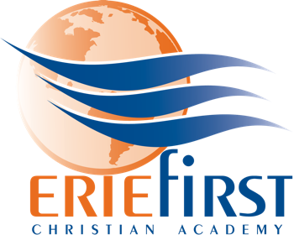

Assistant Women’s Volleyball Coach
Job Description

Erie First Christian Academy (EFCA) is seeking an Assistant Women’s Volleyball Coach for the upcoming 2022/2023 season. This position would assist the Head Women’s Volleyball Coach with the PIAA Varsity Team (A), and be the Head Coach for the PIAA Junior Varsity team. Additionally, the assistant coach would be responsible for assisting the middle school club team when possible and at the direction of the Head Women’s Volleyball Coach.

Overview: It is the desire of EFCA Athletics to be a highly visible platform for the exhibition of Christian character. Our teams play to win, but more importantly to glorify God. We are committed to an environment of encouragement, teamwork, and excellence; not criticism, individualism, or perfectionism.

Contracted by: Administrator

Responsible to: Athletic Director, Head Volleyball Coach

Supervises: student Athletes

Evaluation: Performance will be evaluated by the Athletic Director in accordance with provision in this job description.

Essential Job Functions:

→ Provide counsel to Head Coach as needed during practices/games
→ Teach volleyball skills to program participants as directed by the Head Coach
→ Preparing volleyball court(s) / equipment prior to practices
→ Assisting with the running of practices at the direction of the Head Coach
→ Coaching at any clinics or camps hosted by EFCA
→ Ensuring volleyball equipment / facility is properly cared for
→ Other duties as assigned by Head Coach or Athletic Director

Requirements / Education / Experience:

→ Successful candidate must possess a high school diploma or GED equivalent
→ Candidate must have a valid driver’s license
→ Candidate must be able to supply transportation to practices and home matches
→ Desire to teach the game of volleyball
→ Prior coaching or teaching experience preferred but not required
→ Child clearances must be completed before beginning open gyms or practices

